Rareleaf: Research Findings, Learnings, and Design Justification

1. Problem Definition and User Needs
Indoor plant owners, particularly those cultivating exotic ornamental plants, face consistent challenges in maintaining optimal watering routines. Exotic plants are highly sensitive to over-watering, under-watering, and fluctuations in ambient temperature and humidity. Unlike hardy household plants, many exotic species originate from stable tropical or subtropical climates and therefore demand precise moisture regulation and environmental awareness.
User observations and informal studies indicate that most users rely on manual judgement or fixed watering schedules. These approaches fail to account for real-time variations in soil moisture and surrounding environmental conditions. The problem becomes more complex when multiple plants are involved, as different species and pot sizes require individualized care.
The primary user need identified through this study is a single, reliable system that can automatically adapt to changing indoor conditions, manage multiple plants independently, minimize manual intervention, and provide transparency to non-technical users. Rareleaf is designed to meet these needs through adaptive control, sensor-driven automation, and a user-focused interface.

2. Market Research and Gap Analysis
An analysis of existing indoor irrigation and plant-care solutions reveals a fragmented market. Current offerings generally fall into the following categories:
- Timer-based drip irrigation kits operating on fixed schedules.
- Single-sensor solutions, most commonly soil-moisture-threshold systems.
- Proprietary smart garden pods focused on edible plants rather than ornamental or exotic species.
- DIY IoT-based watering projects with limited safety, scalability, and usability.
Key limitations observed across these systems include: - Absence of per-pot precision watering. - Limited sensor fusion and environmental awareness. - No verification of actual water delivery. - Weak safety mechanisms for indoor use. - Poor adaptability across different plant species. - Feature fragmentation requiring multiple devices.
Market learning indicates that users desire multiple individual features—precision watering, automation, adaptability, safety, and monitoring—but existing products deliver these in isolation. Rareleaf addresses this gap by integrating all essential functionalities into a single cohesive system, eliminating the need for multiple partial solutions.

3. Research Learnings Influencing the Rareleaf Design
Iterative research and system experimentation led to several key design insights:
- Soil moisture alone is insufficient – Ambient temperature and humidity significantly affect soil drying rates, especially for exotic plants.
- Irrigation is a threshold-based biological control problem – Plants respond to environmental ranges rather than continuous linear functions.
- Explainability improves user trust – Users are more comfortable with automation when watering decisions are transparent and interpretable.
- Indoor systems must prioritize safety – Leak prevention, reservoir monitoring, and bounded watering actions are essential.
- Edge intelligence improves reliability – Local processing avoids cloud dependency and ensures uninterrupted operation.
These findings directly shaped the architecture and intelligence of Rareleaf.

4. Machine Learning Integration and Learnings

4.1 Model Selection
Rareleaf employs a Decision Tree classifier as its core machine-learning model. A decision tree is a supervised learning algorithm that uses a hierarchical structure of conditional rules to arrive at decisions. This approach aligns naturally with threshold-based biological systems such as plant irrigation.
Decision Trees were selected due to their interpretability, low computational requirements, suitability for edge deployment, and ability to model non-linear interactions between environmental factors.

4.2 Dataset Source and Preparation
The training dataset was sourced from a professional nursery and contained structured information related to plant watering requirements and environmental preferences. Prior to training, the dataset was cleaned and filtered to retain only parameters directly relevant to indoor irrigation decisions.
The final feature set used for training consisted of: - Soil moisture level - Ambient temperature (surrounding environment) - Ambient relative humidity (surrounding environment)
Irrelevant attributes were removed to reduce noise, and synthetic samples were generated to improve robustness under varying indoor conditions.

4.3 Model Training and Performance
The Decision Tree model was trained using a train–test split evaluation strategy. On the validation dataset, the model achieved a test accuracy of 99.6%, indicating strong alignment between the learned decision rules and nursery-derived irrigation logic.
This performance reflects the controlled nature of indoor irrigation, high-quality domain-specific data, effective feature selection, and the suitability of decision-tree-based logic for threshold-driven plant behavior.

4.4 Real-World Feasibility
Although indoor environments experience variability in temperature and humidity, the Decision Tree model remains robust in real-world deployment. Environmental changes directly influence sensor inputs, which in turn alter the decision path through the tree. This enables dynamic adaptation rather than static scheduling.
To ensure safe operation, Rareleaf integrates rule-based constraints alongside the ML model, including minimum watering intervals, maximum allowable volumes, reservoir-level checks, and manual override capability. Continuous data logging enables future retraining to adapt the system to specific household microclimates.

5. Exotic Plant Considerations
Rareleaf focuses on exotic indoor plants due to their narrow tolerance ranges and sensitivity to environmental stress. These plants typically require stable soil moisture, higher ambient humidity, and protection from over-watering.
Unlike common household plants, exotic species cannot be reliably maintained using generic schedules or single-sensor logic, justifying the need for adaptive, environment-aware irrigation.

Examples of Exotic Indoor Plants Commonly Available in India:
- Monstera Deliciosa
- Calathea
- Fiddle Leaf Fig (Ficus lyrata)
- Peace Lily (Spathiphyllum)
- Areca Palm
- Anthurium
These plants are widely available in Indian nurseries and are known to suffer from improper indoor watering practices.

6. Consolidated Learning Outcome
Based on the research and experimentation conducted, the following conclusions were drawn:
- Sensor fusion is essential for accurate indoor irrigation.
- Decision Tree models provide reliable, explainable, and efficient decision logic.
- High model accuracy is achievable and meaningful in constrained biological systems.
- Exotic plants justify the need for adaptive, environment-aware watering systems.
- A unified system architecture offers significantly greater value than fragmented feature-based solutions.
Rareleaf incorporates these learnings into a single, scalable indoor irrigation platform that combines precision sensing, adaptive intelligence, safety mechanisms, and user-centric design.

7.Hardware Flow (Core Focus)
Raspberry-Pi-based automated water planting system for 4 pots. The system reads soil moisture (capacitive sensors), temperature/humidity, and optionally flow; decides watering via rule/ML; actuates a pump and 4 solenoid valves; displays status on a local touchscreen UI; and runs from a 12.8 V LiFePO4 battery or mains adapter.

7.1 Sensor Integration
The heart of the project is the way sensors are used together. Soil moisture, environment, flow and level measurements are all needed for safe and precise irrigation.
Soil Moisture Sensing
Each pot has a capacitive soil moisture sensor inserted near the root zone. Capacitive sensing is chosen over resistive probes because it is more resistant to corrosion and mineral buildup. The sensor outputs a raw value that the Raspberry Pi reads through an analogue input or dedicated converter. For each pot, a quick calibration is carried out: readings are recorded at a known dry point and at a fully watered point, after drainage. Using these two anchors, the controller maps raw readings to an approximate moisture percentage for that specific pot and substrate.
Once calibrated, the controller can compare each new reading directly against the moisture band defined by the plant profile. For example, if the band is 30-50 percent and the sensor reports 26 percent, the plant is considered dry and eligible for watering, provided timing and safety checks are satisfied.

7.2 Environmental Sensors: Temperature, Humidity and Light
A small environmental module near the plants measures ambient temperature and relative humidity. We utilize digital sensors like the DHT22, which interface directly with the Raspberry Pi’s GPIO pins. A separate light sensor (e.g., BH1750) reports whether the area is in low, medium, or bright light via digital communication.
These measurements provide context for how quickly pots should be drying. The controller uses this data to adjust its expectations; in hot, dry conditions, it anticipates faster moisture loss, whereas in cool, humid conditions, it lengthens the minimum gap between waterings. And also, the plant conditions like which soil is better for plant growth and how much watering is required per day this kind of necessary information will be in UI.

7.3 Flow and Level Sensing
A small hall-effect flow sensor in the main water line allows the controller to measure how much water actually passes into the system during a watering event. When the pump runs, the sensor produces pulses; by counting them, the Raspberry Pi estimates the delivered volume. This is more accurate than controlling only by time and makes it possible to log precise irrigation amounts.
A reservoir level sensor, such as a float switch or an ultrasonic distance sensor, prevents the pump from running dry. If the water level is too low, the controller blocks new watering cycles and instructs the user, via the app, to refill the tank. Optional leak detection, using a simple moisture strip or load cell under the tray, can force an emergency shut-off if unexpected water is detected where it should not be.

7.4 Sensor Fusion and Closed-Loop Control
Periodically, the Raspberry Pi reads all sensors and maintains a state object for each plant: current moisture, time since last watering, recent trend, and current environment. The decision to water is based on this fused information. A typical control cycle for a pot is:
- Query the ADS1115 to get soil moisture voltage.
- Check against the target range and minimum time gap.
- If eligible, trigger the GPIO to open the specific solenoid valve and start the pump.
- Count flow pulses via GPIO interrupts.
- Stop when the volume is reached or moisture returns to the band.

7.5 Block Diagram (Flow chart explanation)
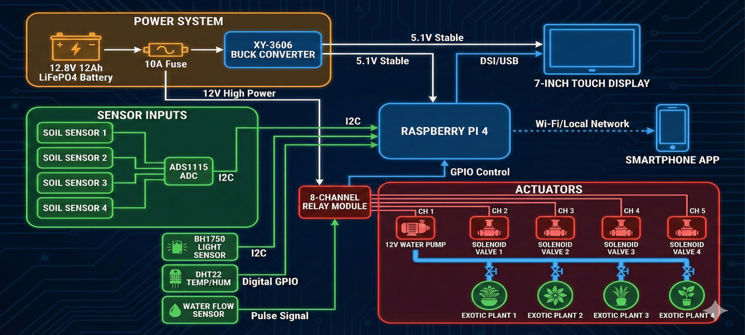
Sensors → ADS1115 ADC → Raspberry Pi 4 → ML Inference (Python) → GPIO Control → Pump/Valves
- Controller: Raspberry Pi 4 Model B (4GB RAM)
- Interface: ADS1115 (16-bit ADC) via I2C
- Sensors: 4x Capacitive Moisture Sensors, DHT22/BME280, Flow Sensor
- Actuation: 5V Relay Module or MOSFETs driving 12V Pump + 4 Solenoid Valves
- ML Engine: Scikit-learn / TensorFlow Lite (running locally on Linux)
Wiring Diagram Summary (4 Pots)
- Moisture Sensors: Analog Output → ADS1115 Inputs (A0–A3).
- ADS1115: VCC/GND/SDA/SCL → Raspberry Pi GPIO Header (Pins 1, 3, 5, 9).
- DS18B20 / DHT22: Data → Raspberry Pi GPIO 4 or 17.
- Pump: IRLZ44N MOSFET or Relay → Raspberry Pi GPIO 18 (PWM capable if needed).
- Solenoid Valves: Driven using ULN2803 or Relay Board on GPIOs 22, 23, 24, 25.
- Power Supply: 12V Adapter for Pump/Valves; 5V/3A USB-C for Raspberry Pi (or 12V-to-5V Buck Converter).
Software Logic (Raspberry Pi 4)
- Input: Python script reads I2C data from ADS1115 and GPIO data from DHT22.
- Process: Normalize data using polynomial calibration.
- ML Integration: Package data into a data frame feature vector. Run local inference using a pre-trained Python model.
- Decision: Predict 'Water' vs 'Wait' and calculate duration.
- Action: Toggle GPIO pins to activate valves/pump.
- Logging: Store data in a local SQLite database and push to mobile app via MQTT/API.

7.6 Hardware Hub and Actuation
The hardware hub is designed to be compact, quiet and safe for indoor use. The Raspberry Pi will be on a small carrier board with connectors for sensors, valves and pump. Power is provided by a 12 V DC adapter to handle the pump and valves, with regulations for logic-level rails.
Water is stored in a small plastic reservoir placed near the plants. A submersible pump pushes water through the flow sensor into a manifold. From there, four solenoid valves route water to individual pots through flexible tubing. When no plant is being watered, all valves are closed and the pump is off. Simple mounting to keep setup neat.

